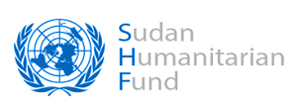
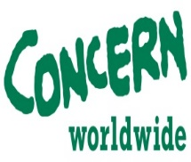
Tender Advertisement
Tender Reference: CWW/SUD/KHT/0000193/2020 - Supply & Transportation of Medical Drugs & Supplies”
Concern Worldwide is an international humanitarian organization that strives for a world free from poverty, fear, and oppression. We deliver life-saving and life-changing interventions to the world's poorest and most vulnerable people. From rapid emergency response to innovative development programming, we go to the hardest to reach places to make sure that no-one is left behind.
Concern intends to award a Contract for the Supply & Transportation of Medical Drugs & Supplies. In the framework of humanitarian programs funded by SHF.
Concern retains the right to accept or reject any offer/proposal prior to the award of contract and to annul the bidding process and reject all offers at any time.
Concern does not bind itself to award the contract to the lowest bidder and reserves the right to accept the whole or part of the offer.
The deadline for submission of tenders is Monday 31st August, 2020, at 14:30 p.m.
Tender opening session will be on Thursday 3rd September, 2020, at 12:00 noon.

The Tender Dossier can be collected from Monday 17th August 2020 from 12 noon at Concern’s Office in Khartoum or electronically by downloading the tender dossier directly from the website www.Sudanbid.com.
Documents:
See the Attached

